A Lagu Damai Project:
Alternative Approaches to Traditional Beekeeping in Bali

Dr. Margret Rueffler, PhD.
William Schrier, B.S.
Nyoman Muskoni, B.S.

Present day situation:

The traditional Balinese methods for harvesting honey are not larvae and hive growth supportive. While the general practice is to only harvest 40% or less of the hive, because of the fact that wild Balinese bees build their hives such that brood cells and honey cells are in the same area of the hive - generally the bottom two thirds are brood cells with larvae and the top third are the honey cells. This differs greatly from western honeybees that build their brood cells in a separate part of the hive from the honey storage cells. As such, the traditional Balinese methods to harvest honey simply include removing the entire section of honeycomb - both brood cells and honey cells - and processing all of it. The honey is extracted and the brood cells are boiled and the larvae are eaten. If new extraction methods can be achieved, hopefully honey harvesting can be done without destroying the larvae or the existing honeycomb, which will hopefully improve hive health and increase honey production.

Changes to be implemented:
- Change traditional practice of destroying large portions of the hive - including honeycomb, eggs, and larvae - in order to harvest honey.
- Improve hive health by reducing the impact of harvesting honey
- Increase honey production
- Increase potential income opportunities through beekeeping
- Increase awareness of current state of global honeybee health and availability of more eco-conscious methods

Requirements:
- Low cost
- Easy setup
- Multiple benefits

Challenges:
- How to build frames to be able to extract only honey yet maintain structure
- How to educate/convince local beekeepers using traditional methods to adopt new approaches
- How to adapt wild bees to alternative hive frames

Experiments to meet Challenges:
- Frame Orientation: Wild Balinese Honeybees usually do not build their nest in boxes with typical western style frames for easy honey harvesting. Additionally, the wild Balinese honeybees have three different methods for building their honeycomb when in boxes - parallel to the long edge, perpendicular to the long edge, and diagonally. As such, Nyoman and William have built two separate boxes - one with frames going parallel to the long edge and one with the frames going perpendicular to the long edge.
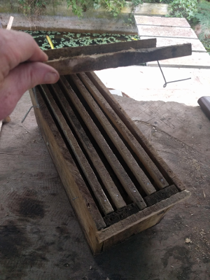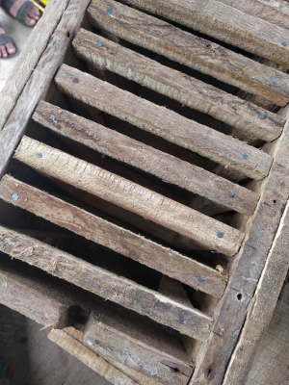
The purpose of this experiment is to see if the wild Balinese bees are more adaptable to one style of frame over the other, and also to see if one frame type is more likely to to cause the bees to construct and fill their honeycomb in any particular ways that might be more conducive to honey harvesting.

- Frame Construction to Facilitate Less Invasive Honey Harvesting: Nyoman and William have built several prototype frames that may allow for the frames to be separated during the harvesting, allowing the larvae to be left and the majority of the honeycomb to remain intact.
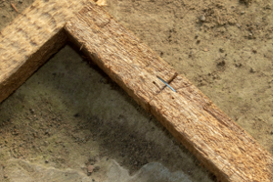 | Method 1: Simple cut, reattached with staple.  While this method is easy and appears strong now, staple guns may not be common and there is high likelihood of the staple corroding. Uncertain as to the long term feasibility of this method.
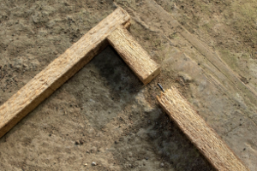 | Method 2: Simple cut, reattached with metal pin.  This method seems much less sturdy and to create the pin a nail was used with the head ground off. This method is already considered one of the least recommended.
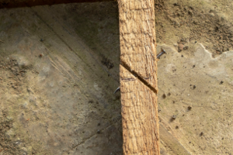 | Method 3: Simple diagonal cut with metal pin.  This method may be the most effective. The cut is easy and should be sturdy long term. The nail was left at full length to see if it protruding on the inside of the frame impacts the honeycomb structure and to remove the need to cut the nail (simplifying the process). Care must be taken to ensure the nail is placed on the ideal angle to hold the joint.
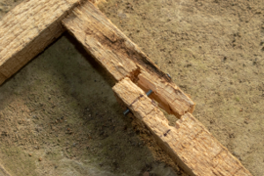 | Method 4: Complex offset cut with metal pin.  This method may be sturdy and the wood used for these bee hives is fairly soft so the cut was fairly easy. The pin used is a nail which was ground off to shorten its length. One potential drawback to this method is that the softness and brittleness of the wood typically used for wild Balinese bee hives may not be feasible long term.
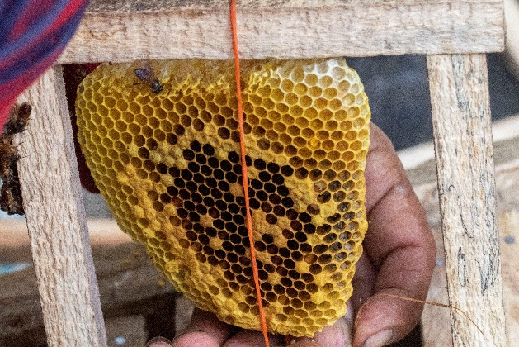 | Method 5: Cut frame at time of honey harvesting.  Due to the softness of the wood and the uncertainty of exactly where the bees will begin honey cells within the frame, the decision was made to leave some frames uncut and only to do so at the time of harvesting. This may not be ideal long term due to the fact that the frames will almost always be cut at different lengths, causing potential problems during harvesting.
[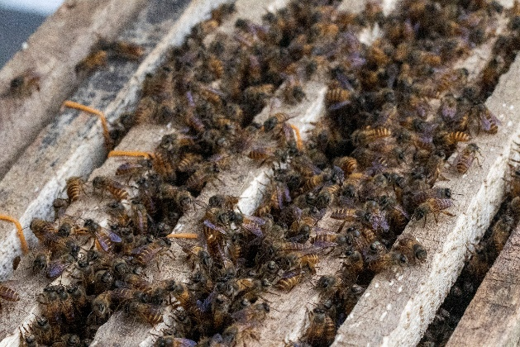 | Method 6: Do not cut frame, but rather remove the honey cells only and leave the brood cells intact in the frame.  This method may actually be the most ideal as it eliminates the need for complex frames that can be disassembled and reassembled repeatedly, the honeycomb will likely be removed and not replaced which will cause some additional effort on the part of the bees to reconstruct those cells, but there may be the same challenge with the other methods. This method will also cause challenges during extraction if attempting to use the centrifuge method.

Mid-Project Assessment:

After several months of allowing the bees to acclimate to the modified boxes with the frames, they are assessed for potential challenges and to ensure the bees are adapting well.

New Challenges Identified:
  - Frame Hanging Method Problematic - the attempt to make the boxes easily modified by hammering nails into the side boards of the box and hanging the frames from those nails is not ideal. The frames become difficult to remove from the nails if the bees build any honeycomb in that area or if the wood swells due to humidity. Alternatively, the frames sometimes fall off the nails and getting them repositioned while the bees are living in the box may not be the easiest. The boxes or the frames may need to be redesigned in order to accommodate western style frames, unfortunately this also means more difficulty for traditional beekeepers to be able to adopt the new frames.

  - Frame Positioning too Close - the spacing used between the frames is close enough that the bees build the honeycomb connecting the adjacent frames (see photograph below). This causes problems when it is time to remove the frames for harvesting as it disturbs the bees more, damages the honeycomb, and will likely cause problems during honey extraction as well. The frames will need to be spaced further apart in order to help discourage the bees from this behavior, but doing so will also reduce the number of frames available in the box, and may also risk providing the bees enough space to revert back to building their honeycomb directly to the box, which would cause even more challenges.
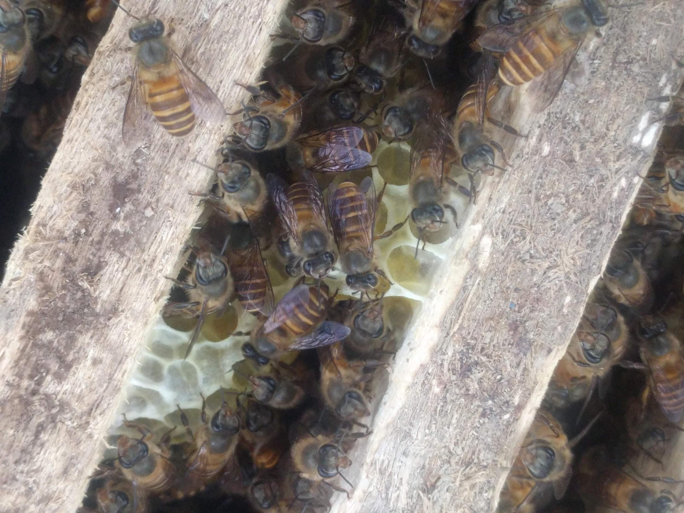

Mid-Project Assessment Conclusion:

The bees seem to adapt fairly well to the modified boxes using western style frames. They quickly reattached the existing honeycomb to the frames and severed the rubber bands that were temporarily holding them in place without any human intervention. The newly build honeycomb appears to be strong and the colony does not appear to be negatively impacted dramatically by the changes.

Unforeseen challenges of the box modifications being less functional than expected, and the bees’ tendency to build honeycomb connecting adjacent frames may be difficult to overcome and may discourage beekeepers from abandoning the traditional methods they are accustomed to.

The original requirements of “low cost” and “easy setup” remain high priorities and the most difficult challenges.

More assessment will be obtained during harvesting to ascertain the long term viability of the project, at which time some adjusted methods and designs may be tested in a second cycle to potentially solve the new challenges identified.

Timeline of Activities:
- 2019.08.07 - Margret, Nyoman, and William meet initially to discuss the situation and the initial ideas for the project. Previous Jiwa Damai volunteer, Michael Lom, has already constructed a prototype centrifuge that could potentially be used to extract honey without destroying honeycomb, but does not address the problem that Balinese bees place both honey and larval cells in the same frame. Nyoman and William begin to discuss options for frames that can be disassembled during honey extraction to avoid destroying larval cells.
- 2019.08.08 - Margret, Nyoman, and William visit Awan Damai, in Gunung Sari to view private bee hives there at 1200 m altitude
- 2019.08.11 - Nyoman and William meet to begin constructing frames as discussed. Decision is made to use Nyoman’s father’s bees in Taro for the test as he has several established hives and an attempt can be made to transfer the bees to a box with the frames in order to reduce delays waiting for new bees to occupy the boxes.
- 2019.08.19 - Nyoman and William meet to continue construction of frames.
- 2019.08.26 - Nyoman and William meet with Nyoman’s father - Pak Fredy - to transfer some existing hives to the new prototype boxes to see if the bees will take to the new frames to build their hive.
- 2019.10.14 - Nyoman and William inspected the hives to see how well the bees are adapting to the frames and to make a mid-project assessment.

